SYSTEM DESIGN
  - SYSTEM ARCHITECTURE DESIGN:
2.1.1 ER Diagram :

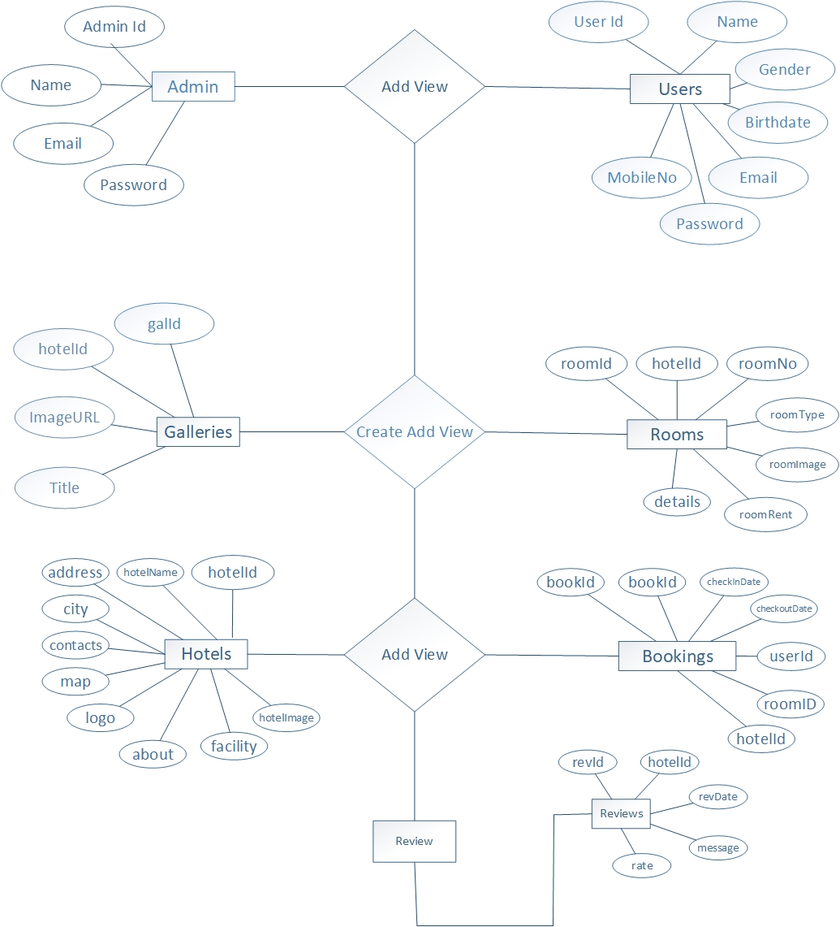

Figure 2.1: ER Diagram
2.1.2 Use case Diagram :
- Admin :

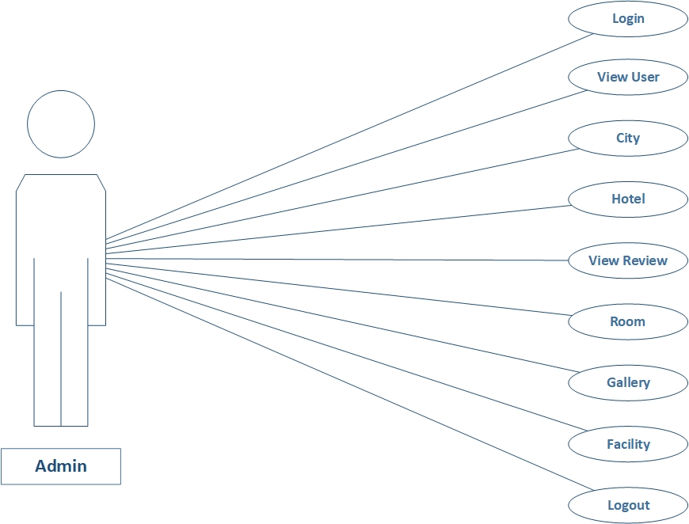

Figure 2.2: Use case Diagram for Admin

- Register:

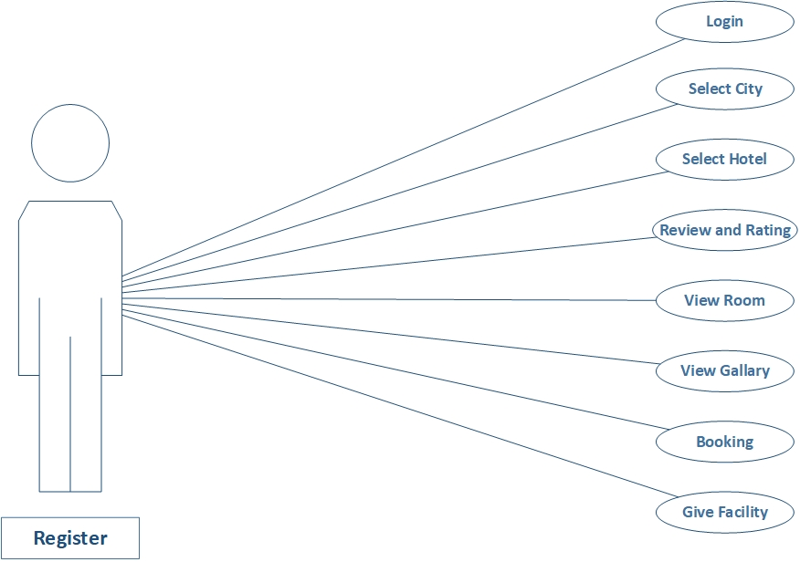

Figure 2.3: Use case Diagram for Register

- Visitor :

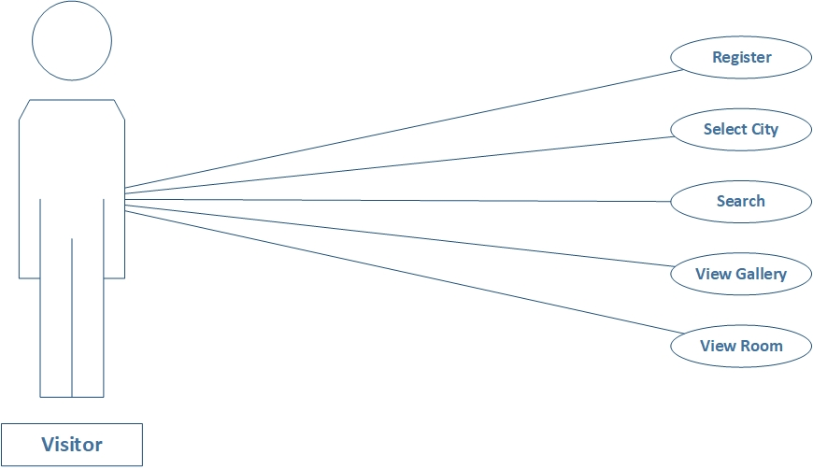

Figure 2.4: Use case Diagram for Visitor

2.1.3 Data Flow Diagram:
a) Context Diagram :

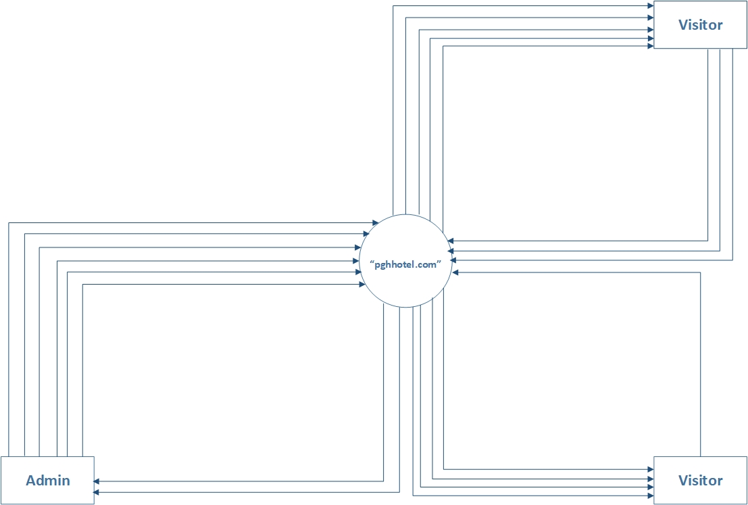
Reg. User

Figure 2.5: Context Diagram
Level 1 Data Flow Diagram :
- Register :
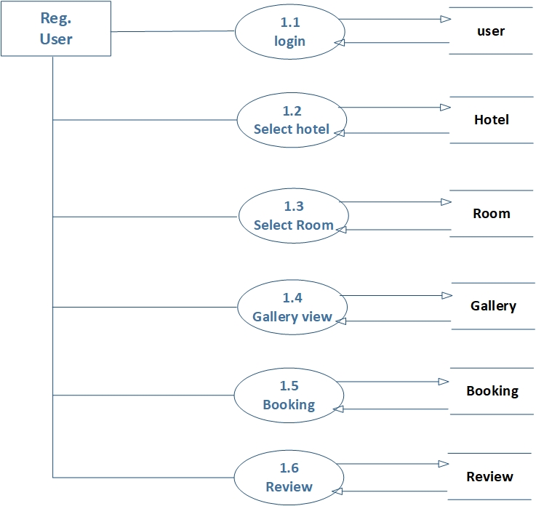

Figure 2.6: 1 - Level Data Flow Diagram

2.1.4 Activity Diagram :

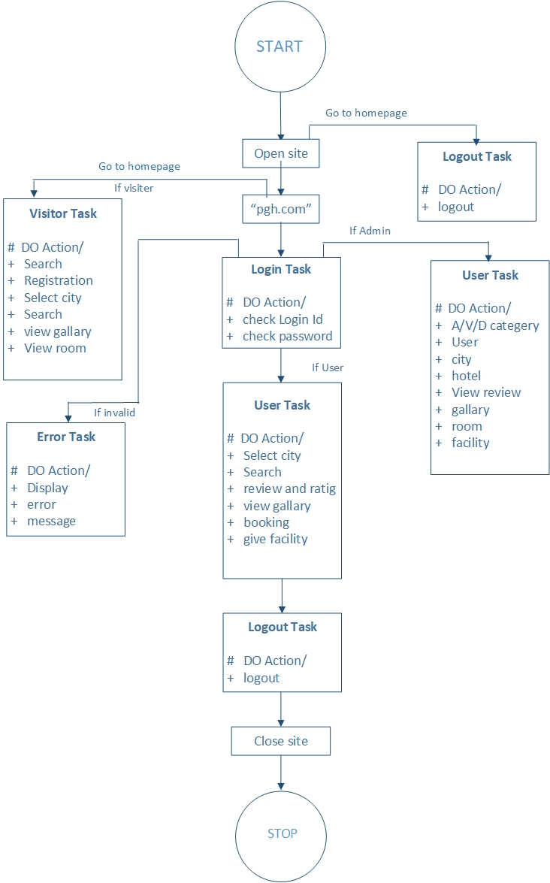

Figure 2.7: Activity Diagram
2.2 DATA DICTIONARY
Table Name: admins
Description: Store admin details
SR. No | FIELD NAME | DATA TYPE | SIZE | CONSTRAINT | DESCRIPTION
1 | adminId | Int | 5 | Primary key | Id of admin
2 | name | Text | 50 | Not null | Name of admin
3 | emailId | Text | 50 | Unique key | Email of admin
4 | password | Text | 30 | Not null | Password of admin

Table Name: galleries
Description: Store galleries details
SR. No | FIELD NAME | DATA TYPE | SIZE | CONSTRAINT | DESCRIPTION
1 | gallId | Int | 5 | Primary key | Id of galleries
2 | hotelId | Int | 5 | Reference key | Id of hotelId
3 | imageURL | Text | 50 | Not null | image of galleries
4 | title | Text | 50 | Not null | Title of galleries

Table Name: users
Description: Store users details
SR. No | FIELD NAME | DATA TYPE | SIZE | CONSTRAINT | DESCRIPTION
1 | userId | Int | 5 | Primary key | Id of users
2 | name | Text | 50 | Not null | Name of users
3 | gender | Text | 10 | Not null | Gender of users
4 | birthdate | Date | - | Not null | BirthDate of users
5 | emailId | Text | 50 | Unique key | Email of users
6 | password | Text | 30 | Not null | Password of users
7 | mobileNo | Text | 10 | Unique key | MobileNo of users

Table Name: hotels
Description: Store hotels details
SR. No | FIELD NAME | DATA TYPE | SIZE | CONSTRAINT | DESCRIPTION
1 | hotelId | Int | 5 | Primary key | Id of hotel
2 | hotelName | Text | 50 | Not null | Name of hotel
3 | Address | M. text | - | Not null | address of hotels
4 | city | Text | 50 | Not null | City of hotels
5 | contactNo | Text | 10 | Not null | Contact of hotel
6 | map | Text | 100 | Not null | map of hotel
7 | logo | Text | 50 | Not null | hotel’s logo
8 | about | M.text | - | Not null | About of hotel
9 | facility | M.text | - | Not null | Facility of hotel
10 | hotelImage | Text | 100 | Not null | Image of hotel

Table Name: rooms
Description: Store rooms details
SR. No | FIELD NAME | DATA TYPE | SIZE | CONSTRAINT | DESCRIPTION
1 | roomId | Int | 5 | Primary key | Id of room
2 | hotelId | Int | 5 | Reference key | Id of hotels
3 | roomNo | Number | 5 | Not null | No of rooms
4 | roomType | Text | 50 | Not null | Type of rooms
5 | roomImage | Text | 50 | Not null | Image of rooms
6 | roomRent | Int | 5 | Not null | Rent of rooms
7 | details | M.Text | - | Not null | Details of rooms

Table Name: bookings
Description: Store bookings details
SR. No | FIELD NAME | DATA TYPE | SIZE | CONSTRAINT | DESCRIPTION
1 | bookId | Int | 5 | Primary key | Id of booking
2 | bookDate | Date | - | Not null | Date of bokings
3 | checkinDate | Date | - | Not null | Date of checkin
4 | checkoutDate | Date | - | Not null | Date of checkout
5 | userId | Int | 5 | Reference key | Id of users
6 | roomId | Int | 5 | Reference key | Id of rooms
7 | hotelId | Int | 5 | Reference key | Id of hotels
Table Name: reviews
Description: Store reviews details
SR. No | FIELD NAME | DATA TYPE | SIZE | CONSTRAINT | DESCRIPTION
1 | revId | Int | 5 | Primary key | Id of reviews
2 | hotelId | Int | 5 | Reference key | Id of hotels
3 | revDate | Date | - | Not null | Date of reviews
4 | message | M.Text | - | Not null | Message of reviews
5 | Rate | Int | 5 | Not null | Rate of Hotel and Rooms
6 | userId | Int | 5 | Reference key | Id of users

